Banking churning Prediction

Dataset: <https://www.kaggle.com/datasets/gauravtopre/bank-customer-churn-dataset?resource=download>

Analyzing the columns to drop to keep useful features

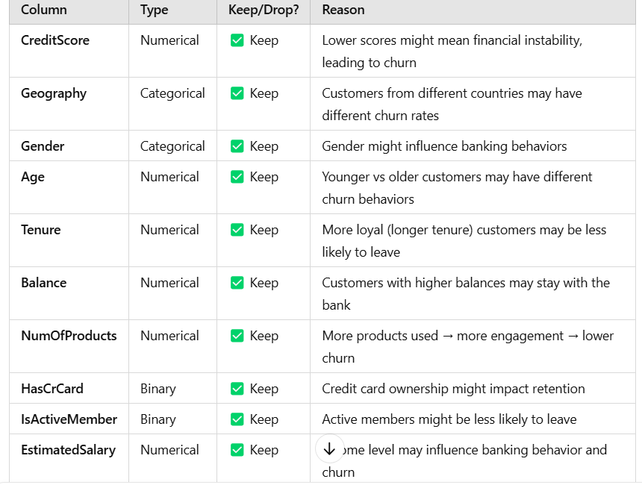

And one more technic is correlation analysis